**AI versus CI**

Pitfalls of the Traditional AI:

Problem solving methods in traditional AI deal with representation of the problem states by symbols and construction of a set of IF-THEN rules to describe the transitions in the problem space. The states of the problem are then matched with the IF part of the rules, and on successful matching the selected rule is the selected rule is fired causing a transition to a new state as obtained from the THEN part of the rule.

To apply the rules until the goal is found, the knowledge rule is enriched with a large number of rules. This results in more search time, and degraded efficiency of the reasoning system. A few IF-THEN rules, and allowing partial matching with IF part mitigates this limitation. Fuzzy logic (FL) enables this. Decision making is based on facts and the level of their precision. The quality of decision may degrade when input facts are imprecise. If inputs come from multiple sources, their level of precision can be improved using data fusion. Traditional AI is not concerned with data fusion. Traditional AI was incompetent to meet the increasing demands of search, optimization and machine learning in information systems and industrial automation. Shortcomings became more pronounced with successive failures of the Japanese project Fifth Generation Computer Systems. The failure of classical AI opened up new avenues for non-conventional models of intelligence in real-world applications. Enormous successes have been achieved through the modeling of biological intelligence, resulting in so-called intelligent systems". These gave rise to a new discipline called **Computational Intelligence (CI)**.

Definition of CI: CI is the study of adaptive mechanisms to enable or facilitate intelligent behavior in complex and changing environments. These mechanisms include paradigms that exhibit an ability to learn or adapt to new situations, to generalize, abstract, discover and associate.

CI comprises of following paradigms:

1. Artificial neural networks (ANNs),
2. Fuzzy systems,
3. Evolutionary computing
4. Swarm Intelligence
5. Artificial immune systems

Artificial Neural Networks (ANN):

ANN, usually called a neural network (NN), is a mathematical or computational model inspired by the structure and functional aspects of biological neural networks. NN is an adaptive system that changes its structure based on external or internal information that flows through the network during the learning. ANNs can be used to infer a function from observations. Broad application categories of ANN are: function approximation, pattern classification, data processing, and time-series prediction.

Basic Structure of ANNs

The idea of ANNs is based on the belief that working of human brain by making the right connections, can be imitated using silicon and wires as living neurons and dendrites.

The human brain is composed of 86 billion nerve cells called neurons. They are connected to other thousand cells by Axons. Stimuli from external environment or inputs from sensory organs are accepted by dendrites. These inputs create electric impulses, which quickly travel through the neural network. A neuron can then send the message to other neuron to handle the issue or does not send it forward.

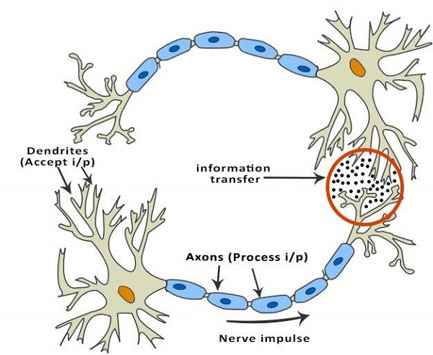

ANNs are composed of multiple nodes, which imitate biological neurons of human brain. The neurons are connected by links and they interact with each other. The nodes can take input data and perform simple operations on the data. The result of these operations is passed to other neurons. The output at each node is called its activation or node value.

Each link is associated with weight. ANNs are capable of learning, which takes place by altering weight values. The following illustration shows a simple ANN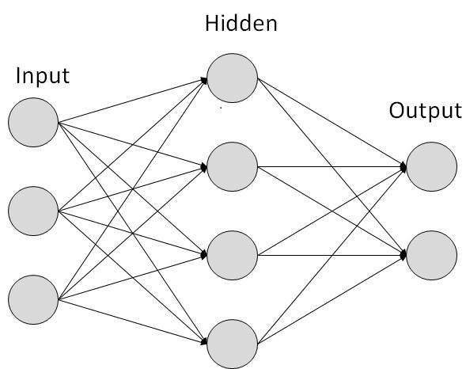

**Applications of neural networks**

1. **Character Recognition** - The idea of character recognition has become very important as handheld devices like the Palm Pilot are becoming increasingly popular. Neural networks can be used to recognize handwritten characters.
2. **Image Compression** - Neural networks can receive and process vast amounts of information at once, making them useful in image compression. With the Internet explosion and more sites using more images on their sites, using neural networks for image compression is worth a look.
3. **Stock Market Prediction** - The day-to-day business of the stock market is extremely complicated. Many factors weigh in whether a given stock will go up or down on any given day. Since neural networks can examine a lot of information quickly and sort it all out, they can be used to predict stock prices.
4. **Traveling Saleman's Problem** - Interestingly enough, neural networks can solve the traveling salesman problem, but only to a certain degree of approximation.
5. **Medicine, Electronic Nose, Security, and Loan Applications** - These are some applications that are in their proof-of-concept stage, with the acception of a neural network that will decide whether or not to grant a loan, something that has already been used more successfully than many humans.
6. **Miscellaneous Applications -** These are some very interesting (albeit at times a little absurd) applications of neural networks.

**Fuzzy Systems**:

Fuzzy Logic tries to capture the human ability of reasoning with imprecise information. In a sense, FL allows the modeling of common sense. FL has an ability to deal with vague systems and its use of linguistic variables. It Models Human Reasoning and works with imprecise statements such as: In a process control situation, “If the temperature is moderate and the pressure is high, then turn the knob slightly right”. The rules have “Linguistic Variables”, typically adjectives qualified by adverbs (adverbs are hedges).

Underlying Theory: Theory of Fuzzy Sets

Intimate connection between logic and set theory.

Given any set ‘S’ and an element ‘e’, there is a very natural predicate, μs(e) called as the belongingness predicate.

The predicate is such that, μs(e) = 1, iff e ∈ S

= 0, otherwise

For example, S = {1, 2, 3, 4}, μs(1) = 1 and μs(5) = 0

A predicate P(x) also defines a set naturally.

S = {x | P(x) is true}

For example, even(x) defines S = {x | x is even}

Applications of Fuzzy Systems

Aerospace: In aerospace, fuzzy logic is used in the following areas −

* Altitude control of spacecraft
* Satellite altitude control
* Flow and mixture regulation in aircraft deicing vehicles

Automotive: In automotive, fuzzy logic is used in the following areas −

* Trainable fuzzy systems for idle speed control
* Shift scheduling method for automatic transmission
* Intelligent highway systems
* Traffic control
* Improving efficiency of automatic transmissions

Business: In business, fuzzy logic is used in the following areas −

* Decision-making support systems
* Personnel evaluation in a large company

Defense: In defense, fuzzy logic is used in the following areas −

* Underwater target recognition
* Automatic target recognition of thermal infrared images
* Naval decision support aids
* Control of a hypervelocity interceptor
* Fuzzy set modeling of NATO decision making

Electronics: In electronics, fuzzy logic is used in the following areas −

* Control of automatic exposure in video cameras
* Humidity in a clean room
* Air conditioning systems
* Washing machine timing
* Microwave ovens
* Vacuum cleaners

Finance: In the finance field, fuzzy logic is used in the following areas −

* Banknote transfer control
* Fund management
* Stock market predictions

Industrial Sector: In industrial, fuzzy logic is used in following areas −

* Cement kiln controls heat exchanger control
* Activated sludge wastewater treatment process control
* Water purification plant control
* Quantitative pattern analysis for industrial quality assurance
* Control of constraint satisfaction problems in structural design
* Control of water purification plants

Manufacturing: In the manufacturing industry, fuzzy logic is used in following areas −

* Optimization of cheese production
* Optimization of milk production

Marine: In the marine field, fuzzy logic is used in the following areas −

* Autopilot for ships
* Optimal route selection
* Control of autonomous underwater vehicles
* Ship steering

Medical: In the medical field, fuzzy logic is used in the following areas −

* Medical diagnostic support system
* Control of arterial pressure during anesthesia
* Multivariable control of anesthesia
* Modeling of neuropathological findings in Alzheimer's patients
* Radiology diagnoses
* Fuzzy inference diagnosis of diabetes and prostate cancer

Securities: In securities, fuzzy logic is used in following areas −

* Decision systems for securities trading
* Various security appliances

Transportation: In transportation, fuzzy logic is used in the following areas −

* Automatic underground train operation
* Train schedule control
* Railway acceleration
* Braking and stopping

Pattern Recognition and Classification: In Pattern Recognition and Classification, fuzzy logic is used in the following areas −

* Fuzzy logic based speech recognition
* Fuzzy logic based
* Handwriting recognition
* Fuzzy logic based facial characteristic analysis
* Command analysis
* Fuzzy image search

Psychology: In Psychology, fuzzy logic is used in following areas −

* Fuzzy logic based analysis of human behavior
* Criminal investigation and prevention based on fuzzy logic reasoning

**Evolutionary computing**

EC models natural evolution, where the main concept is the survival of the fittest. In natural evolution, survival is achieved through reproduction. Offspring, reproduced from two parents. It contain genetic material of both parents, hopefully the best characteristics of each parent. Those individuals that inherit the bad characteristics are weak and lose the battle to survive. For example: In some bird species, a hatchling manages to get more food, gets stronger and kicks out all its siblings from the nest to die.

**Applications of EC:**

**Optimization:** Gas pipeline transmission, multiple-fault diagnosis, robot track determination, schedule optimization, load distribution by an electric utility

**Classification**: Evolution of neural networks, rule-based machine learning systems for pipeline operations and classifier systems for high-level semantic networks

**Swarm Intelligence (SI)**

SI is originated from the study of colonies (of ants, bees and termites, etc.) or swarms of social organisms flock of birds, school of fish. Studies of the social behavior of organisms (individuals) in swarms prompted the design of very efficient optimization and clustering algorithms. SI is an innovative distributed intelligent paradigm optimization problems. Applications of SI include combinatorial optimization, function approximation, clustering, optimization of mechanical structures, and solving systems of equations.

**Artificial Immune System (AIS)**

AISs are biologically inspired models for immunization of engineering systems. The pioneering task of AIS is to detect and eliminate non-self-materials, called antigens, such as bacteria or cancer cells. The AIS also plays a great role to maintain its own system against dynamically changing environment. The immune systems thus aim at providing a new methodology suitable for dynamic problems dealing with unknown or hostile environments. Areas of applications of AIS are: Classification, clustering, data mining and anomaly detection.